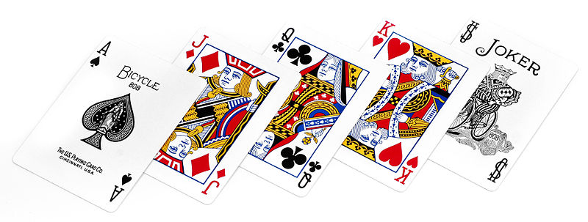

LEGEND PARK TENNIS CLUB

Come be Social

CARDS/GAMES NIGHT

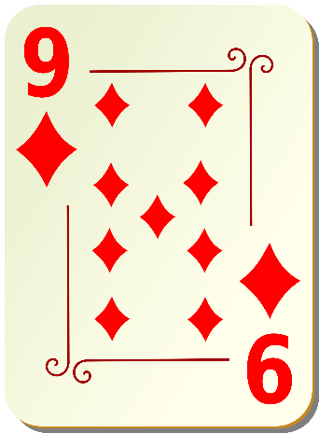Saturday Night - 6th Aril, 2019

7pm till 10.30pm

Bar will be open – No BYO

Bring Some Food to Share

Kids Welcome

Euchre, 500, Gin Rummy, Poker, Bridge

Scrabble, Uno

To name just a few of the games we might play

